

**Daily Coal Stock Analytics and Forecasting using ML Models**

MINI PROJECT REPORT

**Submitted To:**

**Dr. Piyush Chauhan**

**Submitted by:**

**Pranita Dadhe**

**22070521099**

**VIIth , C** **Academic Year:** 2024–25

**1. TABLE OF CONTENT**

**2. Abstract 3**

**3. Keywords 3**

**4. Introduction 4**

4.1 Why I Chose This Dataset 5

4.2 Dataset Description 5

4.3 What the Dataset Contains 5

4.4 Problem Statement 5

4.5 Project Objectives 6

4.6 Novelty of the Research 6

**5. Literature Review 7**

Literature Review Table (with references) 7

**6. Methodology / Proposed System 9**

6.1 Data Collection 9

6.2 Data Cleaning and Preprocessing 9

6.3 Model Design / System Architecture 9

6.4 Training and Evaluation 9

6.6 Tools, Libraries, and Frameworks Used 9

6.7 Pseudocode 10

**7. IMPLEMENTATION 11**

7.1 Implementation 11

7.2 Technologies and Platforms Used 14

7.3 Challenges Faced and Ways to Mitigate Those Issues 14

7.4 Sample Outputs / Visual Results 15

7.5 Streamlit Dashboard Development 20

**8. RESULTS AND DISCUSSION 22**

8.1 Experimental Setup (Hardware/Software Environment) 22

8.2 Exploratory Analysis Results 22

8.3 Visual Insights 22

8.4 Interpretation of Results 23

**9. CONCLUSION AND FUTURE SCOPE 25**

**10. REFERENCES 26**

## **2. Abstract**

The bulk of Indian electricity is produced by thermal power stations, which utilize huge amounts of coal, and so the air is only a little dusty and grey. However, it is necessary to have coal on hand in large amounts to prevent the chance of blackouts but supply chain challenges can happen, in the form of sluggish trains, unforeseen winter demand or random stock of coal available at the various power plants, and hence supplying dangerously small quantities of coal in the coal bins. This paper examines the manner in which these levels of coal, as per the different plants, change over time, provides significant information about these relative changes in these levels, and exudes predictive models to show which ones may be the future and may be the potential levels of coal as in the case of fullness in the coal stocks in the coal storage yard may be next week. The current research problem is focused on the exploratory data analysis (E.D.A.) of the data set whose spatial concentration levels of coal the number reached of more than 360,000 daily historical records, (aother minor time slice of the past, a date in the fading pages of the past, The dustbanded old ledger). We cleaned and willed the data and filled in holes on the data sets and then had visual data of the data sets which could show how the data changed and deviated in quantities of coal at other locations, by coal sections and by transport, and that is the method of conveyancing we found to be most effective low level concerning whether in this data available. This stock of coal in train was then forecasted by the plants terms of furnishing working output, on Random Forest Regression prediction giving a still greater degree of precision, the stocks of the data might be frankly contemplated revealing of much success, or such low degrees as in the black coals but one may easily see most effectively all the levels in the R 2 = -9995. K-Means Clustering sorted the coal stations in the manner that were appear better healthy section, medium rate, etc. And also formulated its predictions ranks. We have divided these predictions of the forest but these are probably the most Sure (Or Cake Chosen Show).

## **3. Keywords**

Coal Stock, Machine Learning, Regression, Forecasting, K-Means, Prophet

## **4. Introduction**

Power plants which use coal continue to provide most of the power in India, their stacky heaps continuously pumping heat into the atmosphere through the grid of the country. To this day, more than 70 percent of the power generation in India is coal-fired. This is the reason it is necessary to regulate coal supplies and retain. a sufficient inventory is essential in ensuring that the lights are on around the whole country. The availability of coal at power plants.changes are in a state of continuous flux determined by real time variables such as daily fuel requirements, daily shipments, transport routes,quality of coal, import dependency and the load factor of the plant--as in keeping eye on the gauge of a furnace.rise and fall through the day. As the fuel stock gets below normal levels, power plants get into a critical condition.or even super critical condition, and with the national grid trembling--lights flashing in a tempest. TheCoal stock numbers are announced by the Ministry of power and the Central Electricity Authority (CEA) on a daily basis, but very sparingly.and convert that untidied information into actual information-science instruments--numbers that lie in heaps, like untouched heaps of black dust, on a. spreadsheet. Spotting shortages or trends normally requires an eye on it by the operators, therefore.longer--as not finding out that a bin is empty till it has been lying there all morning. By analyzing this data Using contemporary data analytics and machine learning software, we can discover new insights that help to hone the supply chain. plan, guide resources, and direct emergency coal reallocation, such as locating an unexpected before it goes to the yard it is short. The project explores the Daily Coal Stock data, following its trends, and so on. trends 2018 to 2025—as the numbers light up and dim over the years. Through Exploratory Data Analysis (EDA), we investigate important factors of operation which include; daily coal demand, transport. transports by rail and road or sea, dependent local and imported coal, and such performance measures as. PLF%. More complicated models like the Random Forest Regression can be used to predict the future stock values based on. operational data, the grouping approaches of power plants are based on the degree to which the plants are able to maintain coal.on hand. Another time-series forecasting model that we are using is Prophet which predicts the stock of coal in the country. will vary within the past 30 days, following its daily increase and decrease as on a gauge. This study gives government agencies, coal ministries, energy planners, and thermal plant operators riddled, practical. insights by identifying where the risks are, predicting shortages before they occur and showing new trends. that hand check mopse—as the gradual disappearance of supply lines on a low control-room monitor. BlendingPredictive modeling using EDA, the project develops a complete analytical pipeline that retains the coal supply of India. conclusions that are firmly anchored in information such as tracing every shipment dust mine to busy (port).

### **4.1 Why I Chose This Dataset**

1. It is essential on a national level, as it must concern itself with direct lights and grid sustenance.
2. It is comprehensive and formal and the plants report daily on their condition, sector and the movement of the shipments by rail or truck.
3. The 2017-2025 period provides enough time to see the long-term changes and trends based on seasons such as the rise in summer temperatures.
4. It contributes to predicting whether the shelves will have some remaining stocks and will help in planning of merchants in their day to day activities.

### **4.2 Dataset Description**

1. The data is supplied by the **India Data Portal** which is the source of the data on **the daily stock of coal in the thermal power stations in India.**
2. Link : <https://indiadataportal.com/p/power/r/mop-coal_stock-pl-dl-aaa>
3. **Coverage**: Indian thermal plants (State, Central, Private sectors) all major ones.
4. **Period**: 2018–2025 (daily)
5. **Format**: Tabular (date, categorical, numeric KPIs)

### **4.3 What the Dataset Contains**

Key fields (indicative):

1. **date, state_name, state_code, sector, utility, power_station_name**
2. **mode_of_transport** (Rail, Road, Sea, Pithead, MGR, etc.)
3. **capacity (MW), daily_requirement, daily_receipt, daily_consumption**
4. **indigenous_stock, import_stock, total_stock, stock_days**
5. **normative_stock_days, req_normative_stock, plf_prcnt**
6. **is_critical (where available), remarks**

### **4.4 Problem Statement**

Even when the information exists, the daily figures of stocks of coal scarcely give us the requirements of tomorrow; in gaps in the returns, the alternative forms of returns and a backward method of wrestling with forecasts make it absolutely useless, a kind of dead weight on the return of coal-mine stock few things are so needed as correct quantifications of stocks. What the industries desire is an integrated way of cleaning the coarse registry, observing tendencies and indications of stocks, predicting, per plant, and predicting the aggregate of stocks in nationland next week or two.

### **4.5 Project Objectives**

1. Know how states, industries and transportation connect and move through their patterns and how to connect those patterns to PLF in the same way you would examine traffic lights changing across a busy intersection.
2. Determine separable and notable operating conditions and stress of the system. As an example: Where the heat is so quick to rise, or where the pressures are so near limits.
3. The overall amount of inventory in each plant being predicted by a machine learning model- visualize crates organized in a row and have the model calculated on its own.
4. Group the plants in terms of the healthiness of their stocks such that one is able to deal with the most dangerous plants first-imagine identifying the down beat, any of the contaminated leaves before the infection becomes widespread.
5. Predict 30 days of stock of the nation using a time-series model. Keep an eye on minute advances and retreats in the stocks just as one would observe quick changes in any heart beat..

### **4.6 Novelty of the Research**

One unified pipeline integrating an EDA + ML regression + clustering + time-series forecasting model, trained on the official India plant-level daily data, and comparing between ML and DL in terms of analytics of coal operations.

## **5. Literature Review**

Summary: Traditional time series models such as ARIMA are conceptually simple to understand but can be confused by complex nonlinear interactions of various factors, whereas machine learning is more precise but is less sensitive to coal stock levels accumulated darkly in the yard, and models demand or emissions. Few studies associate empirical plant forecasting and national forecasting, and breakdowns of results of hazards…

### **Literature Review Table (with references)**

|  |  |  |  |  |
| --- | --- | --- | --- | --- |
| **Ref. No.** | **Method Used** | **Findings** | **Results** | **Limitations** |
| [1] | ARIMA | Monthly coal consumption prediction | Short term forecasting possible | Not suitable for non-linear stock data |
| [2] | Linear Regression | Relation between coal stock and generation efficiency | R² ≈ 0.85 | Fails on dynamic fluctuations |
| [3] | Simulation Thermal Model | System behaviour modelling in coal plants | Performance estimation possible | Cannot predict stock levels |
| [4] | Time Series Trend Analysis | Indian coal production prediction | Detected seasonal trends | Single variable only |
| [5] | ML Regression | Predict emission in coal plants | Good pollutant forecast | Not used for coal stock |
| [6] | Dataset Creation + ML Features | Created ML ready dataset for Indian plants | Enabled ML training | No prediction model built |
| [7] | ML for CO₂ emission | Predicting CO₂ based on coal parameters | Supports environmental insights | Not related to stock |
| [8] | Policy + Data Analytics | How India can reduce coal dependency | Strategic planning guidance | No numerical ML model |
| [9] | Hybrid SSA + LSSVM | Long term coal consumption forecast | High accuracy forecasting | High computation complexity |
| [10] | ML Model for Indian Coal Quality Improvement | Improve utilization of high ash coals | Better performance of coal | Focused on coal quality not stock |
| [11] | Blockchain + IoT System | Real-time monitoring of coal supply chain | High transparency and traceability | Doesn’t do stock prediction |
| [12] Proposed Work | Random Forest + Prophet + KMeans | Full EDA + ML prediction + Forecasting | R² = 0.9995 | Deep Learning not effective |

## 

## 

## 

## 

## 

## 

## 

## 

## 

## 

## 

## **6. Methodology / Proposed System**

### **6.1 Data Collection**

Dataset downloaded from the India Data Portal (Daily Coal Stocks), 2018–2025.

### **6.2 Data Cleaning and Preprocessing**

1. The date column was converted to a datetime type, and all the data was ordered by time.
2. dropped columns with more than 30 percent of missing data.
3. imputed by median numeric variables such as daily_requirement, plf_prcnt and stocks with numeric values that had a gap between the observations.
4. Eliminated duplications and left fifteen clean columns to model..

### **6.3 Model Design / System Architecture**

1. The level of EDA is oriented on frequency plots, box and hist charts, correlation heatmaps, and sector clustered analysis: transport: state.
2. Regression level involves the use of the random forest model to forecast total stock using the operational inputs.
3. Level clustering K-Means daily_requirement, total_stock, normative_stock days and plf prcent to grouping items at risk.
4. Making predictions To predict the total stock at the national level summed up daily within a period of 30 days in the future.
5. The ANN, LSTM, and 1D-CNN models are put side by side in deep learning tests and compared..

### **6.4 Training and Evaluation**

1. **Train/Test:** 80/20 split regression.
2. **Measures:** R2, MAE, RMSE (regression); inertia, visual separation (clustering).
3. **Forecast:**graphical fit and element statistics (trend/weekly/yearly).

### **6.6 Tools, Libraries, and Frameworks Used**

1. **Language/IDE:** Python, Jupyter Notebook.
2. **EDA**; seaborn, numpy, matplotlib, pandas.
3. **ML:** scikit-learn (RandomForestRegressor, KMeans)
4. **Forecasting**: prophet
5. **DL:** tensorflow/keras (ANN, LSTM, CNN)

### **6.7 Pseudocode**

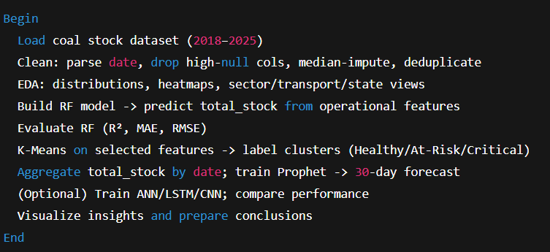

## 

## **7. IMPLEMENTATION**

### **7.1 Implementation**

1. **Load & Inspect:** .info(), .shape, .isnull().sum(), .describe().

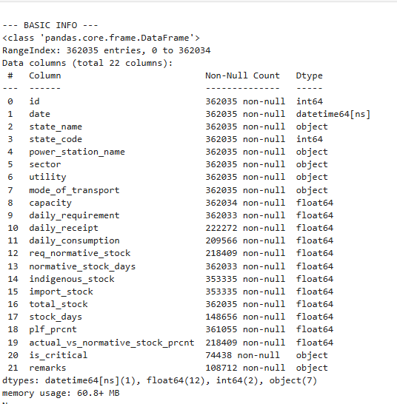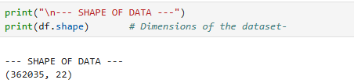

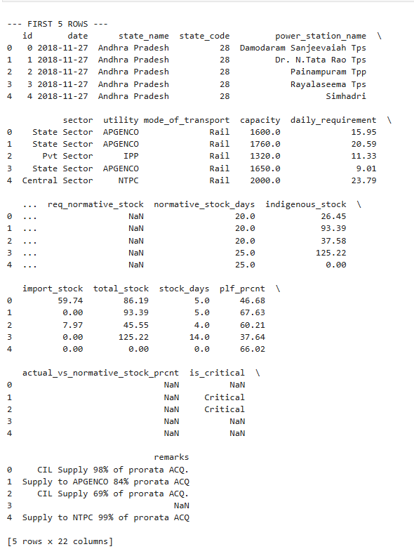

1. **Preprocess:** convert date, drop high-null columns, **median impute**, deduplicate.

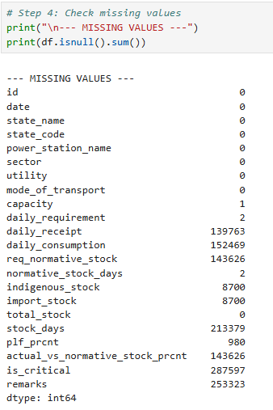

1. **Exploratory Data Analysis (EDA):**
   1. Categorical study – The bar charts indicate the top states in respect to number of plants in them, the proportion for each sector and the transport means among which rail appears to use the largest share amounting to about 72%.
   2. Numerical study – Show distribution plots and boxplots of such variables as normative_stock_days, total_stock, and plf_prcnt in oder to observe for outliers.
   3. Correlation heatmap – for observing the interrelationship between capacity, daily needs, total stock. Bivariate comparisons – Comparison of capacity contra PLF (%) and Variation in stock levels through different means of transport.
2. **Model Training and Evaluation:**
   1. We used a RandomForestRegressor (with 200 trees and random_state=42) to predict the total coal stock from operational features, such as daily fuel intake and storage conditions.
   2. Thus, the data was divided into training and test, in the proportion of 80/20. The R 2 Score, Mean Absolute error (MAE) and RMSE were used to evaluate the performance.
   3. Findings: The R 2 of the Random Forest Model was approximately 0.9995, which means a remarkably good predictive power is the ability to read the characteristics of the data with an almost perfect level!
   4. We applied unsupervised K-Means clustering with 3 clusters to the power plants, which were identified with Elbow Method, to group the power plants into Healthy, At-Risk and Critical clusters.
3. **Forecasting Future Stock:**
   * 1. We tabulated the daily stock figures by date, and the grouping of the figures was by date.
     2. We trained the model of the Facebook Prophet on the next 30 days coal stock prices.
     3. This was finished using forecast plots (learning to predict the model itself) and then analyzing the components to visualize the way the predicted trends will change.
4. **Deep Learning Trials:**
   1. ANN model gave quite good results as it was able to capture some of the variation.
   2. Models trained on LSTM and CNN did not work well as the data was noisy, with inconsistent bursts and between periods that disrupted their timing.
5. **Streamlit Dashboard Development:**
   1. We have developed a live Streamlit dashboard to visualize the analytics of coal stock, and the information has been integrated with an interactive experience, which is live and updated.
      1. Stock data comparison of the state level.
      2. Time series trends.
      3. Sector and Transport Mode analysis.
      4. Projection on 30 days worth on the stocks.
   2. This enables the clients to visualize data on real time and this assists the leaders in the power industry and coal industry in analyzing their activities.

### **7.2 Technologies and Platforms Used**

**Table 2. Technologies and Platforms Used**

|  |  |
| --- | --- |
| **Category** | **Tools / Technologies Used** |
| Programming Language | Python |
| Data Analysis Libraries | pandas, numpy |
| Visualization | matplotlib, seaborn |
| Machine Learning | scikit-learn |
| Forecasting | prophet |
| Deep Learning | tensorflow/keras |
| Platform | Jupyter Notebook |
| Data Source | India Data Portal (Daily Coal Stocks) |

### **7.3 Challenges Faced and Ways to Mitigate Those Issues**

1. **Missing/Noisy Data:** high-null columns were dropped; median imputed.
2. **Scale & Outliers:** tree-based RF resistant; capped extreme outliers in plots.
3. **Temporal Heterogeneity**: aggregated national series of stable forecasting indicators.
4. **Model overfitting:** out-of-sample test set; early termination ofDL; variated RF size.
5. **Sequence Weakness:** LSTM/CNN unhealthy because of plant-level noise; RF + Prophet.

### **7.4 Sample Outputs / Visual Results**

1. **State Distribution: Number of unique plants of top states.**

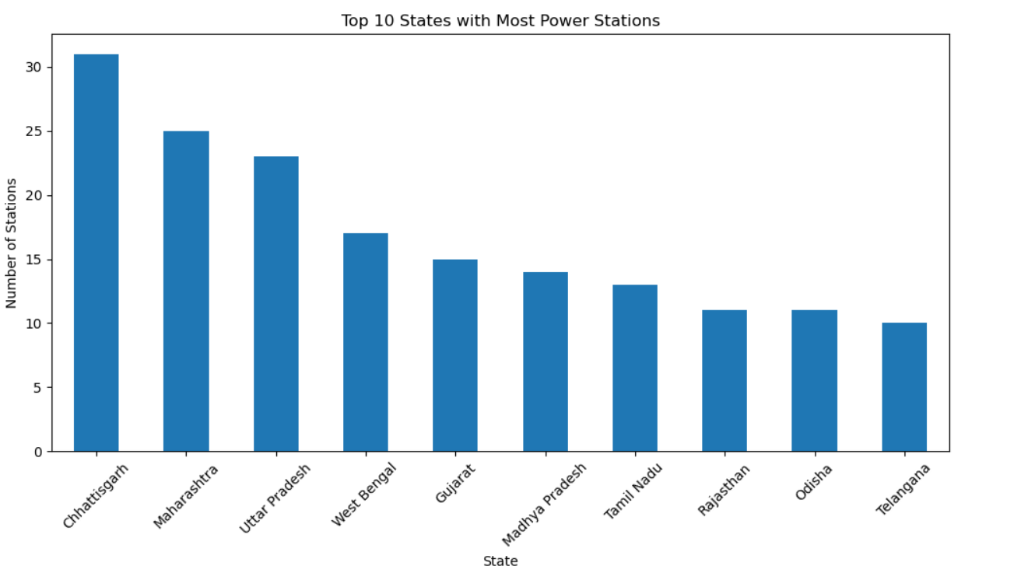

1. **Mode of Transport: Pie of Rail/Road/Sea/Pithead/MGR shares.**

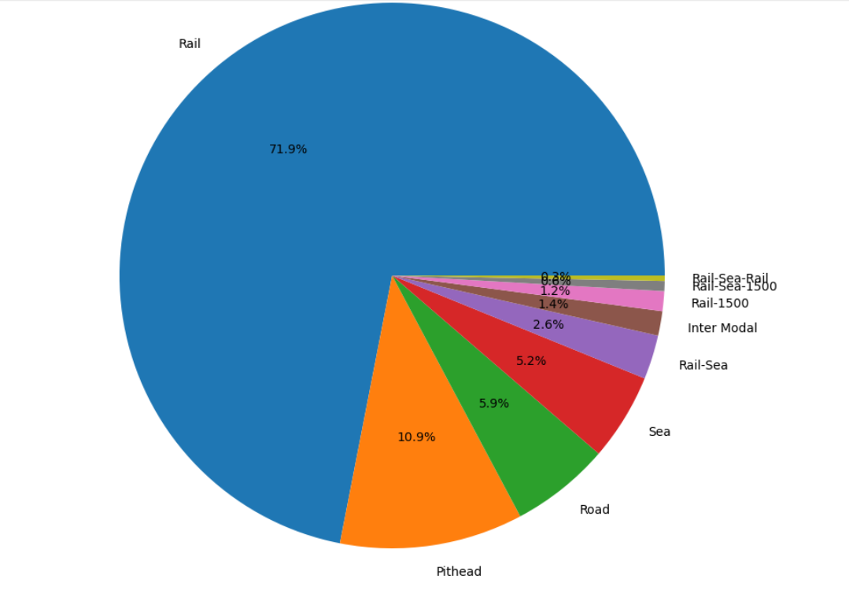

1. **Sector-wise Central/State/Private Counts of Plants**.

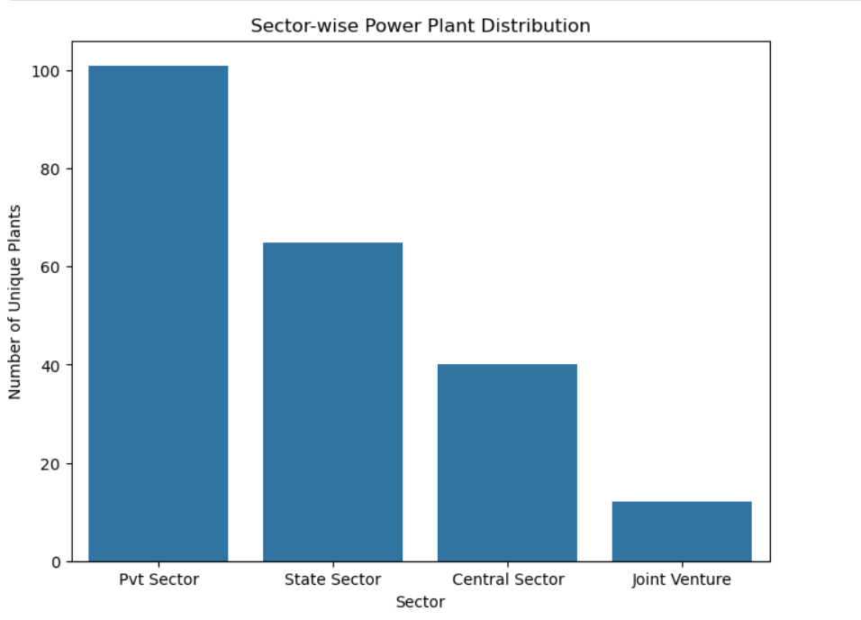

1. **Normative Stock Days: Peaks at 15/ 20/25/30 days.**

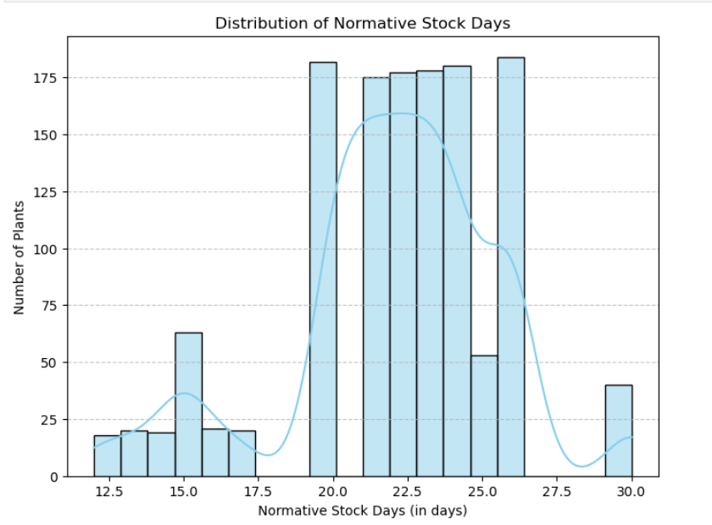

1. **Total Stock: Boxplot and high outlier (overstocking cases).**

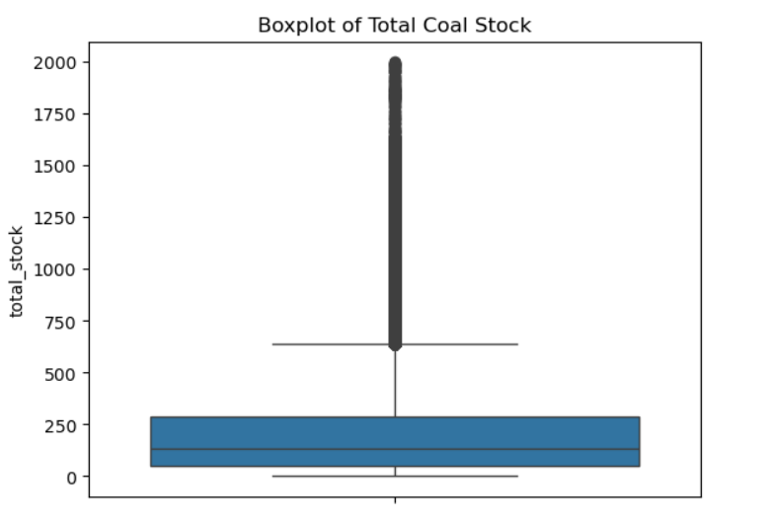

1. **PLF%: Bimodal- zero idle/retired, 4080% operating plants.**

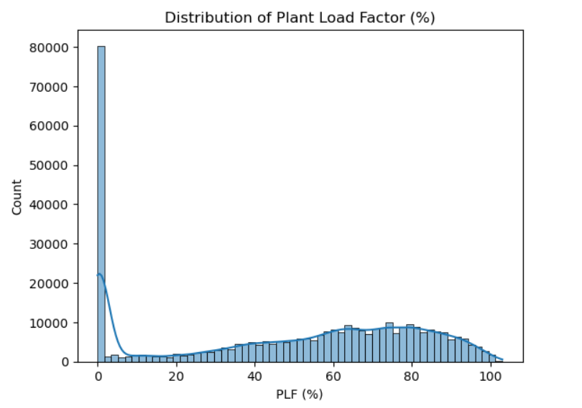.

1. **Correlation Heatmap: strong capacity dollardaily requirement, indigenous dollar total stock; weak links PLF.**

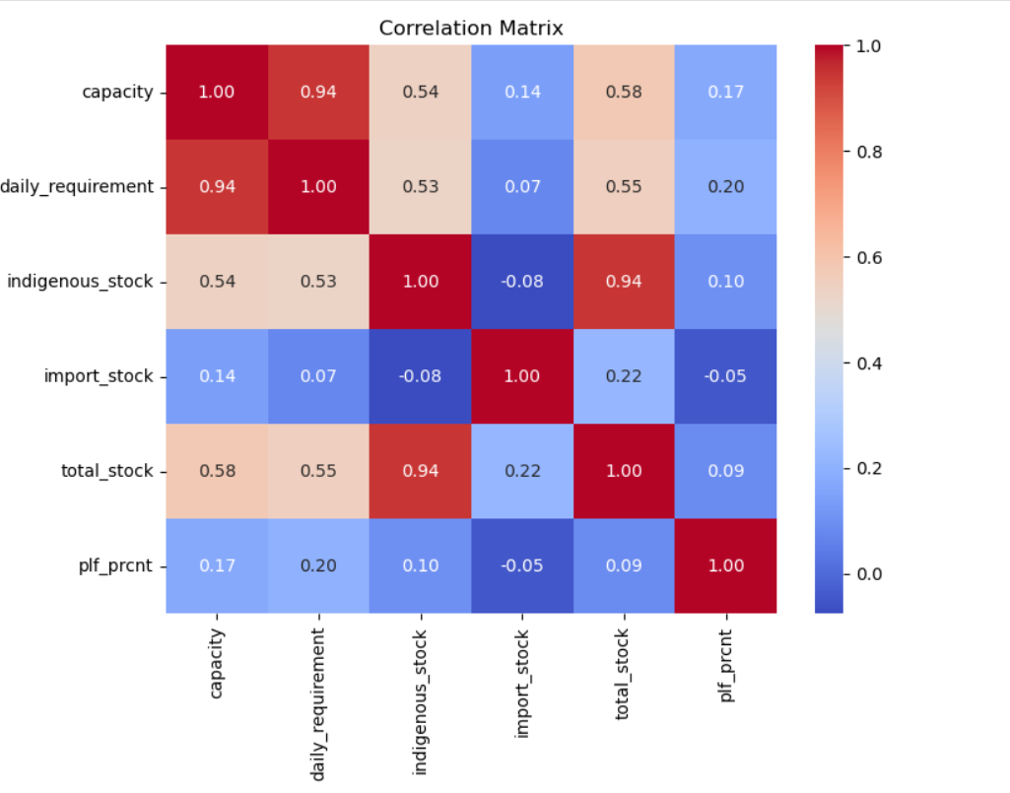

1. **Capacity vs. PLF** by industry does not take a straight line--the PLF oscillates wildly even within plants with the same capacity, but the Private and Central plants are concentrated at the high end whilst the State plants trail behind.

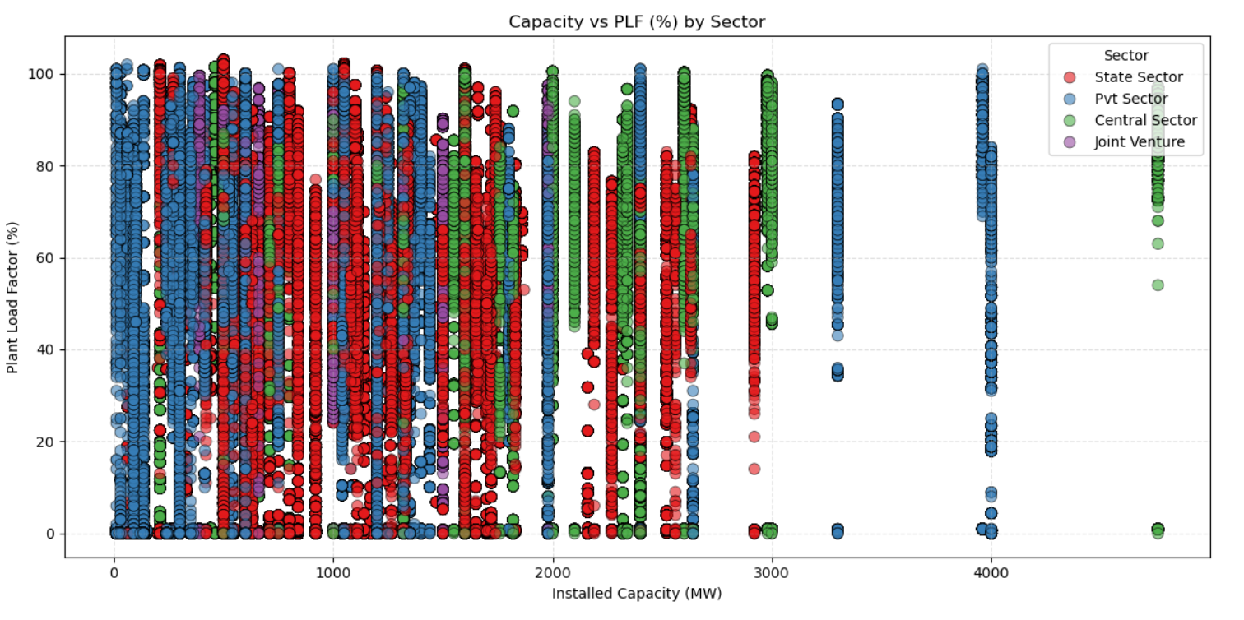

1. **Pithead and Sea-based transport modes** exhibit greater variation in stock and greater peaks with Rail exhibiting moderate and constant stock distribution.

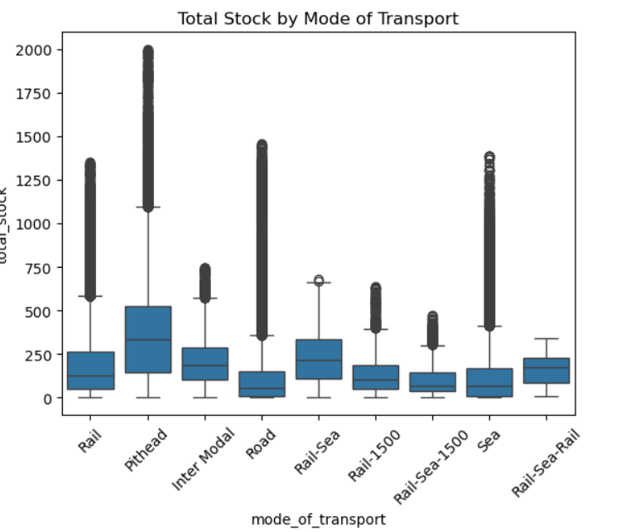

1. **Time Series:** 1 national total stock trend + 7 day MA; Prophet forecast + components (weekly/yearly).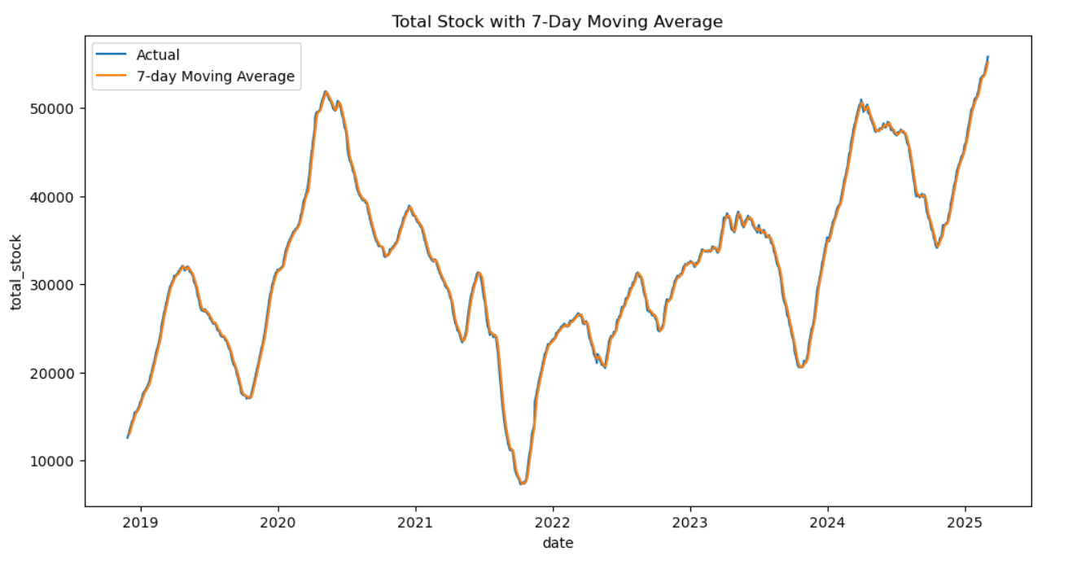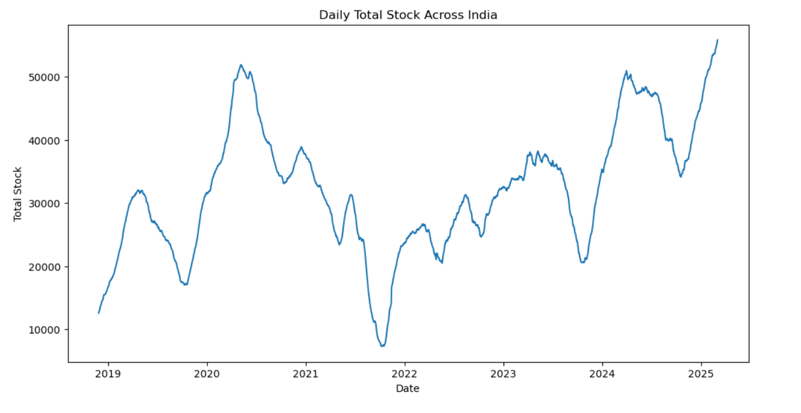

### 

### 

### 

### 

### **7.5 Streamlit Dashboard Development**

To present trends in coal stocks and information in real time that moves with the arrival of new data, we created an interactive dashboard in Streamlit. There is a wide range of analytical viewpoints available on the dashboard: maps of coal stocks by state, daily trending charts, cross-sector comparisons and changes in coal stock by mode of transportation, just to mention a few. One may narrow down the results by selecting the date, state, industry or mode of transport such as an analysis of plants according to type of delivery, i.e. factories associated with shipments by rail. The list of forecasted values by the Prophet model comes after the chart, which attracts attention to the expected trend in the coal stock in the coming days. The dashboard can give the user an easy to understand quick and intuitive answer to the questions they want to know and give a clear picture of the answers to policy advisers or plant managers.

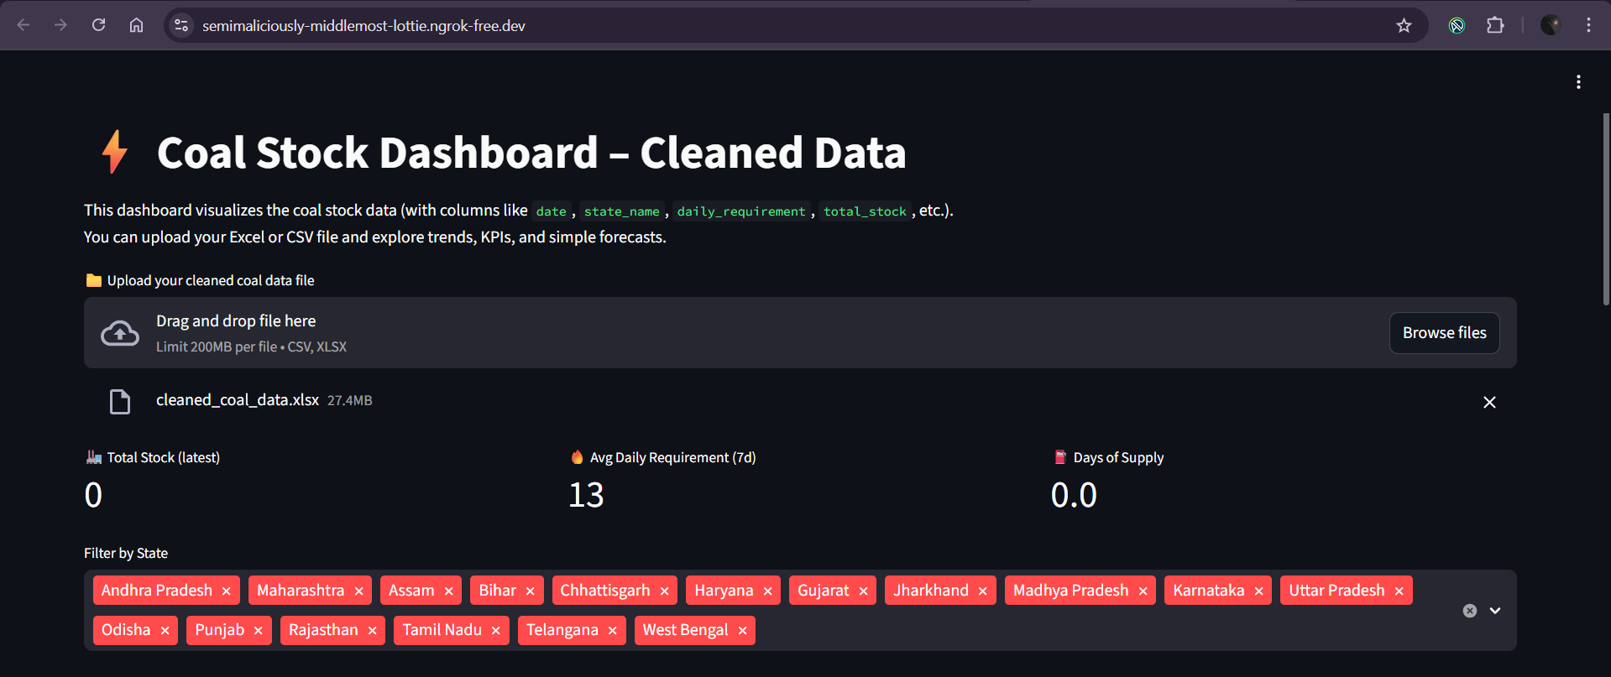

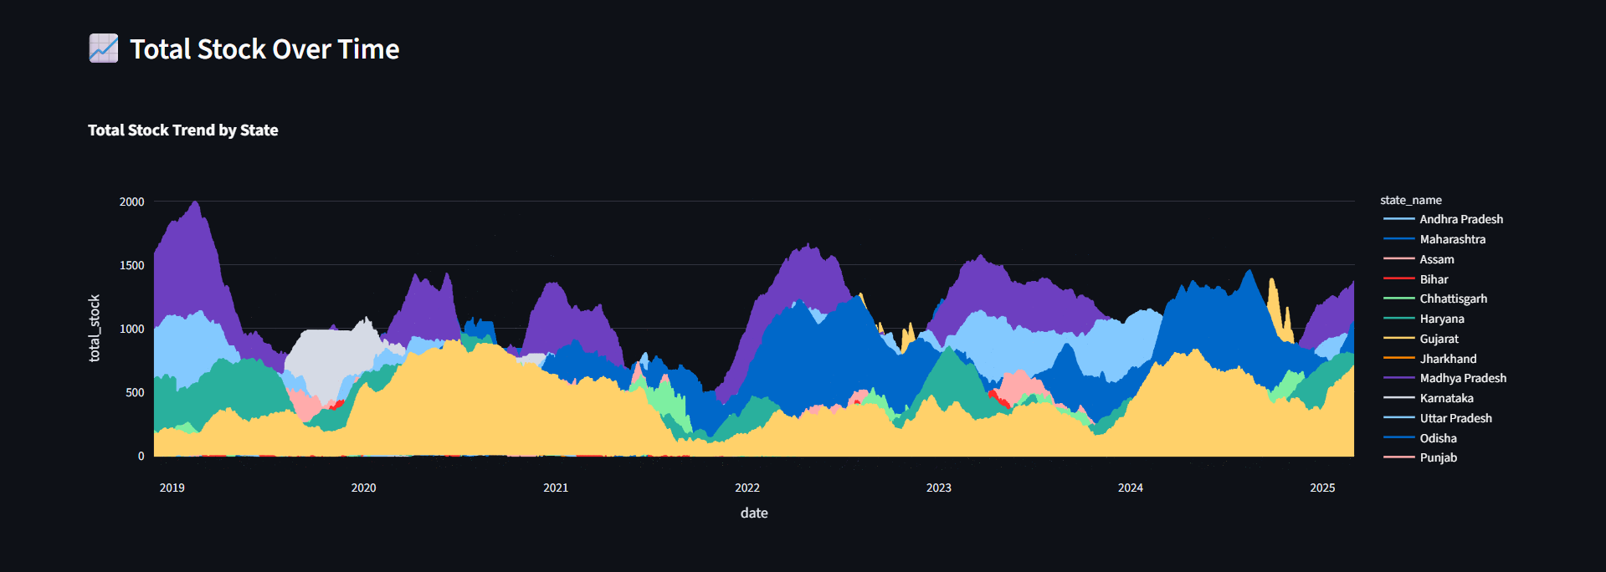

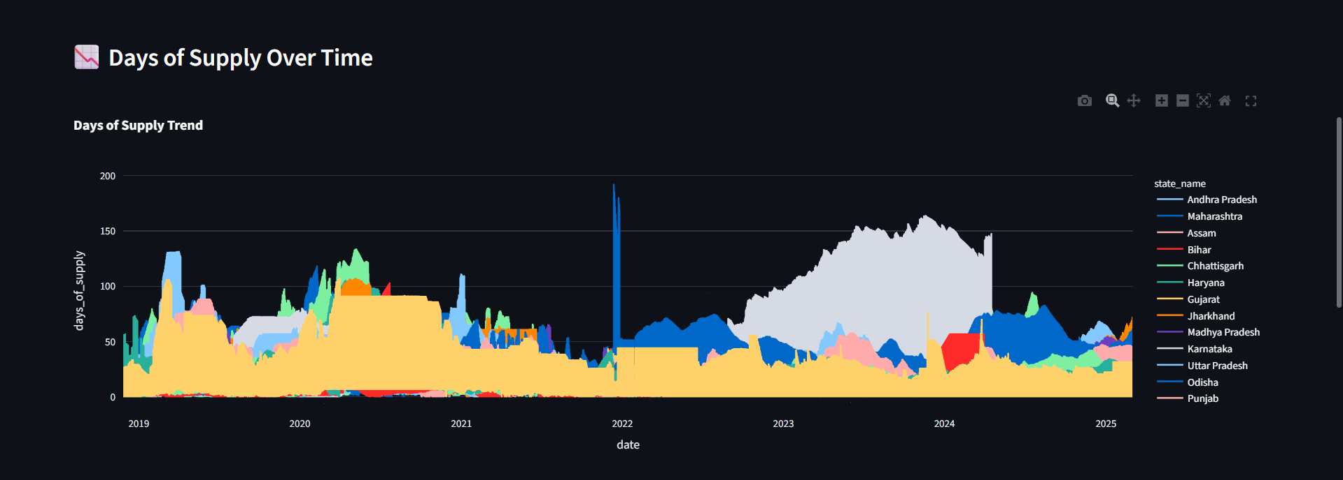

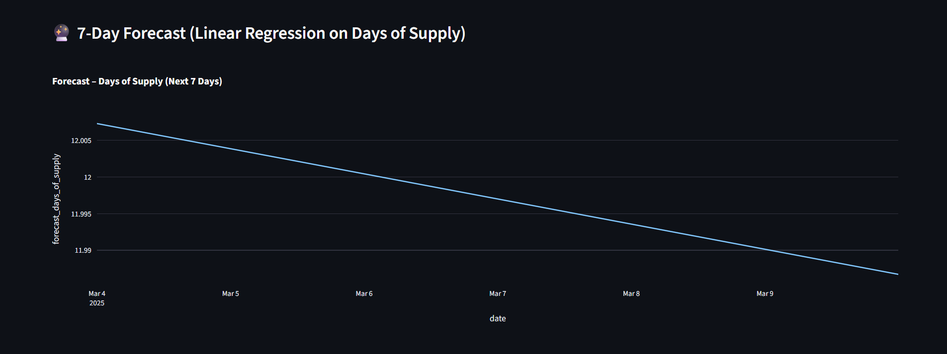

## **8. RESULTS AND DISCUSSION**

The accuracy of prediction based on ML results is very high. Output forecasting depicts the variation of coal stock with time.

|  |  |  |
| --- | --- | --- |
| **Model** | **Metric** | **Value** |
| Random Forest Regression | R² | **0.9995** |
| ML Forecasting (Prophet) | 30-day trend | Increasing with seasonal dips |
| Deep Learning (LSTM/CNN) | R² | Negative (Not suitable) |

### **8.1 Experimental Setup (Hardware/Software Environment)**

Windows 11, Intel i5, 816 GB RAM, Python 3.x, Jupyter Notebook; pandas, numpy, matplotlib, seaborn, scikit-learn, prophet, tensorflow/keras.

### **8.2 Exploratory Analysis Results**

1. There is a high density of plants in the **top states** (e.g., Maharashtra, Uttar Pradesh, Chhattisgarh).
2. **Rail** prevails in logistics; pithead plants have more stable stocks; sea/road less.
3. **Normative stock days** tend to have clusters at policy setpoints (15/20/25/30).
4. **PLF** distribution draws attention towards idle populations and operating populations.
5. **Correlations**: requirement leads to capacity; native stock impetuses overall inventory in numerous situations than imports.

### **8.3 Visual Insights**

1. **Elbow Method recommended 3 clusters.**
2. **Cluster profiles:**
   1. **Healthy: increased stocks, constant PLF.**
   2. **At-Risk: medium stocks, fluctuate PLF/requirements.**
   3. **Critical: stock that is continuously low; supply should be given priority.**
3. **Prediction Prophet (30-day): slight uptrend with weekly cyclical (highs on weekdays, lows on weekends) and annual cycles (mid-year upsurge, end of year downturn).**

### **8.4 Interpretation of Results**

1. Random Forest Regression outperforms in the relationship of inputs to total stock (R²=0.9995, MAE=0.55, RMSE=4.42) to plan what-if scenarios (e.g., what does addition of +10% indigenous receipts to the stock do?).
2. **Analysis using Clustering to determine the Plant Groups basing on Coal Consumption and Stock Patterns.**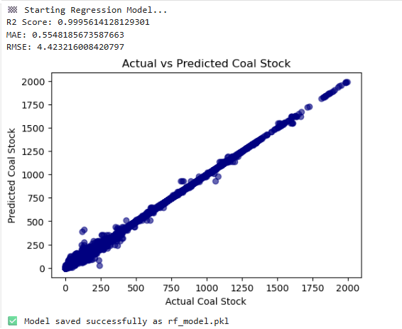
   1. Elbow Method with drop in inertia - k=3 indicates the steepest inclination therefore 3 clusters is op.

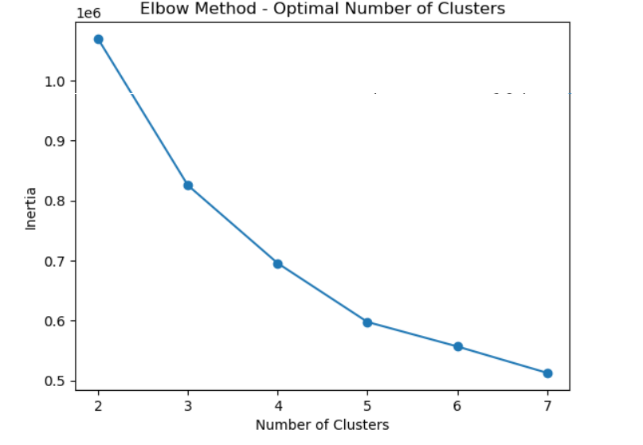

* 1. K-Means (k=3) clustering in plants is based on requirement/day, total stock, stock days and PLF%. Cluster patterns are characterised by a clear separation of low demand plants, medium and high demand/high stock plants.

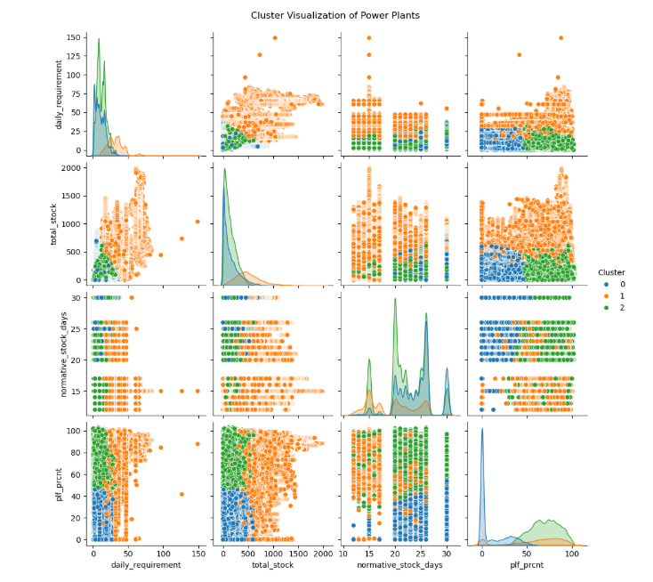

1. **Time Series Forecast on Total Coal Stock (Next 30 Days)**
   1. Prophet decomposition reveals that coal stock based behaviour is not random but rather seasonal and cyclical with recognisable weekly recurrence patterns and annual recurrence patterns.

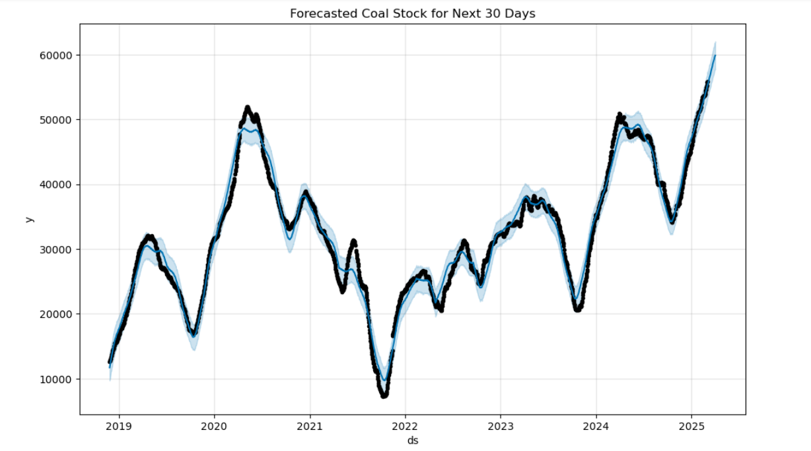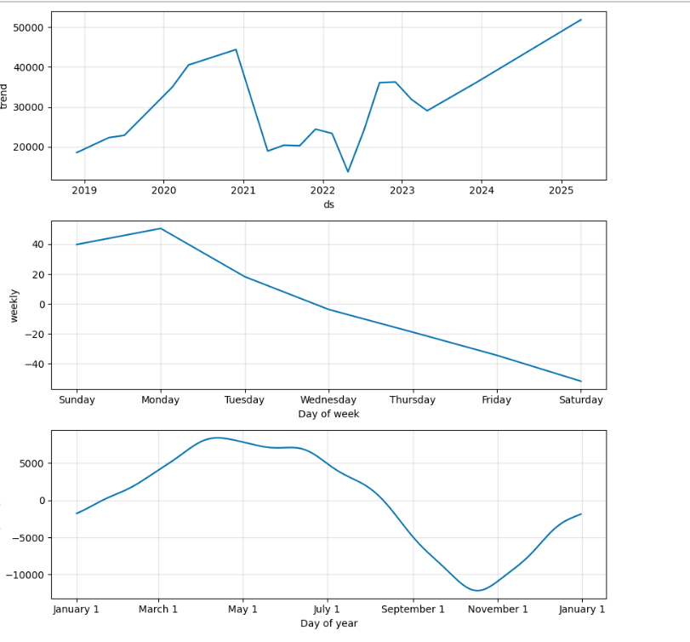

1. Tabular ML + classical time-series methods were successful against Deep Learning (LSTM/CNN) that was overfitting on poor long-range plant sequences and significant noise.

## **9. CONCLUSION AND FUTURE SCOPE**

**Conclusion:**

We built a pipeline of analysis on the daily coal stock data of India - EDA to RF regression to K-Means clustering to Prophet forescasting - of each ton of coal, the grain of black dust on its length. The Random Forest model had done almost perfect away predictability as to the total stock of plants, K-Means presented helpful aggregates to risk cohorts and Prophet presented a clear 30-day national forecast, which the model seasonally patterns like the waves rolling in. The use of DL sequence models was not of any real benefit in this case.

**Future Scope:**

1. See the possibility of bringing together variables that imply real-time logistics, such as the location of every rake, invoicing mine output and weather facts into your inventory analytics.
2. Test hybrid forecasers, mixed as Prophet with XGBoost or and Temporal Fusion Transformer and inject more time-like feature into them, where you provide them with huge Monday sales jumps in the inputs.
3. Launch a Streamlit or Power BI dashboard, which transmits automatic alerts when the quantity of stock in your warehouse goes below critical level plates.
4. Take geo-analytics of the mine and put corriodores and detect and relieve bottlenecks.

## **10. REFERENCES**

[1] R. Kumar and R. Jilte, “A simulation model for thermal performance prediction of a coal-fired power plant,” *Int. J. Low-Carbon Technologies*, vol. 14, no. 2, pp. 122–130, 2019.  
 [2] A. Gangwar, D. Rathore, and P. K. Tripathi, “Forecasting coal production in India: A time series approach,” *Journal of Data Applications*, 2024.  
 [3] M. Mohammadi, D. Saloglu, H. Dertli, et al., “Data-driven modeling for the prediction of stack gas concentration in a coal-fired power plant in Türkiye,” *Water, Air, & Soil Pollution*, 2024.  
 [4] Y. Ding, J. Wong, S. Patel, D. Mallapragada, G. Zang, and R. Stoner, “A dataset of the operating station heat rate for 806 Indian coal plant units using machine learning,” *arXiv preprint*, 2024.  
 [5] A. Prakash and S. K. Singh, “CO₂ emission prediction from coal used in power plants: A machine learning-based approach,” *Iran Journal of Computer Science*, 2024.  
 [6] MIT Energy Initiative, “How can India decarbonize its coal-dependent electric power system?,” *MITEI Report*, 2024.  
 [7] W. Sun, Z. Siqin, A. Wang, R. Diao, G. Xu, and S. Song, “Prediction of coal demand for long-term power system planning based on hybrid SSA and LSSVM algorithms,” *Applied Sciences*, vol. 15, no. 16, p. 8948, 2025.  
 [8] A. Singh, D. S. Panwar, S. K. Maurya, A. Oraon, S. Srivastava, and S. Dixit, “A machine learning approach for significant utilization of high-ash Indian coals by metal chloride modification,” *Scientific Reports*, 2025.  
 [9] “Blockchain-based coal supply chain management system for thermal power plants,” *Discover Computing*, 2025.